

**MyContag**

Group 13

Names : Gema Hafizh Maulidi

Muhammad Alfabel

Class : 3SE2

Faculty : Susi Maulidiah, ST, M.Kom

Semester : 3

CEP CCIT

FAKULTAS TEKNIK UNIVERSITAS INDONESIA

2023

**PROJECT ON**

**MyContag**

**Developed By**

1. Gema Hafizh Maulidi
2. Muhammad Alfabel

**MyContag**

Batch Code : 3SE2

Star Date : Monday, November 27, 2023

End Date : Thursday, December 14, 2023

Name of Faculty : Susi Maulidiah, ST, M.Kom

Names Developer :

1. Gema Hafizh Maulidi
2. Muhammad Alfabel

Date of Submission : Friday, December 15, 2023

**CERTIFICATE**

This is to certify that this report titled “MyContag” embodies the original work done by Gema Hafizh Maulidi and Muhammad Alfabel. Project in partial fulfillment of their course requirement at NIIT and CEP CCIT-FTUI UI.

Coordinator:

Susi Maulidiah, ST, M.Kom

**ACKNOWLEDGEMENT**

Praise the presence of Allah SWT for his permission, so that the author can complete the project with the title "MyContag". Appreciation and thanks to the writer give to Mrs. Susi Maulidiah, ST, M.Kom. as a faculty of class 3SE2 and other teaching staff who always help. Thank you also to fellow students who have supported and also thank you for being acolleague in education at CCIT-FTUI.

The task of this project the author made with the aim to complete the assessment of learning in CCIT-FTUI. With this paper the author hopes to provide benefits to readers and listeners so as to increase knowledge and insight.

Finally, the writer realizes that this project is far from perfect. Therefore, the authors request suggestions and criticisms that are constructive for perfection and hopefully useful for us all.

Aamiin.

**SYSTEM ANALYSIS**

**System Summary :**

This is an Android based image storage application. This application can add images, update images, and delete images. This application is very well designed by the creator starting from its UI appearance which makes users feel comfortable. This application is made with Java language and UI from Android Studio.

**ACTIVITIES LIST**

|  |  |  |  |  |  |
| --- | --- | --- | --- | --- | --- |
| No. | Activity Description | Planned Date of Completion | Actual Date | Responsibility | Remarks |
| 1 | Creating the Home Page | 29th Nov 2023 | 1st Dec 2023 | Abel |  |
| 2 | Creating the Splash Screen | 2nd Dec 2023 | 3rd Dec 2023 | Gema |  |
| 3 | Creating the Add Activity | 5th Dec 2023 | 6th Dec 2023 | Gema |  |
| 4 | Cretaing the Update | 9th Dec 2023 | 9th Dec 2023 | Gema and Abel |  |
| 5 | Creating the Delete | 11 st Dec 2023 | 11st Dec 2023 | Gema |  |
| 6 | Creating the Required Features | 12nd Dec 2023 | 12nd Dec 2023 | Abel and Gema |  |
| 7 | Complete all design xml | 13rd Dec 2023 | 13rd Dec 2023 | Abel and Gema |  |

**DATABASE DIAGRAM**

This table is quite straightforward, with id serving as the primary key. The name, phone_number, and description columns are all text fields.

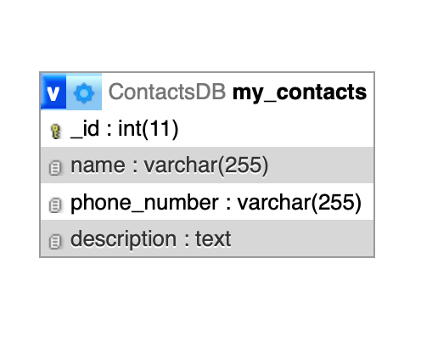

**FLOW DESIGN OF APPS**

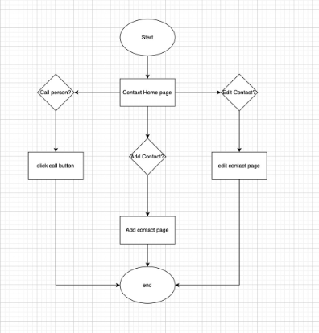

**PREVIEW OF APPS**

* Home List Page

This page contains photos/images that have been added via the Upload page and there is also a floating button to move to the Upload page

**PREVIEW OF APPS**

****

* Add contact

On this page contains a EditText which serves to enter the value of the data column column, then there is a save button that will function to save the entered data

* Edit Contact

The "update" button will function to change the data that has been saved, the user needs to change it first in the filling column, then the user will click "update" and the data will change

* Delete Contact

The "delete" button will function to delete stored contact data

**CONFIGURATION**

**Hardware :** Intel® Core™ i5-10300H 16GB RAM

**Operating System :** MacOs and Windows 11

**Software :** Android Studio, Microsoft Word, Microsoft Power Point

|  |  |  |
| --- | --- | --- |
| **PROJECT FILE DETAILS** | | |
| **No** | **File Name** | **Remarks** |
| 1.  2.  3. | MyContag.rar  Project 1 Q2_3SE2_Group 11_MyContag.docx  PPT_ Project 1_Q2_3SE2_Group 11_MyContag.ppt | Web folder contains android studio syntax to create Mycontag  The Paper of our project  Our Power Point presentation file |